**Bunurong Day on Country  
Cultural Heritage Training**



**Landcare volunteers**

**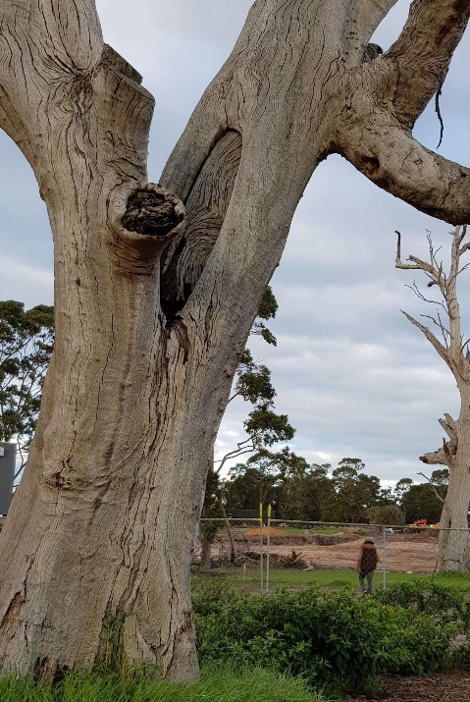Wednesday 18 March, 9am-4pm  
Bus tour starting and leaving from Bunurong Land Council,   
395 Nepean Highway, Frankston**

Discover the deep connections the Bunurong people have to their country on this guided bus tour that will visit several site visits around their ancestral home of the Mornington Peninsula.

**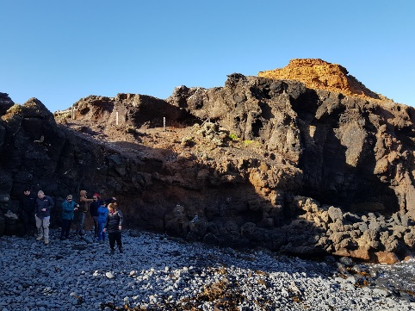**Engage in valuable cultural heritage discussions, which will explain how and when to engage Traditional Owners, legislative requirements and what to look for when dealing with a potential heritage site as part of an on-ground project

The event is funded by the Victorian Government and supports volunteers working in Landcare and other community environmental groups.

Booking essential as numbers are limited. Lunch provided.

**Bookings and more information:**

[**www.ppwcma.vic.gov.au/events/bunurongtraining2020**](http://www.ppwcma.vic.gov.au/events/bunurongtraining2020)

**Details: Barry Kennedy, Regional Landcare Coordinator  
P: 9971 6506 l M: 0447 821 559| E: barry.kennedy@ppwcma.vic.gov.au**

****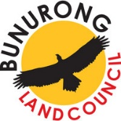FB_greyINSTAGRAM_greyTWITTER_grey

**Port Phillip & Westernport Catchment Management Authority  
03 8781 7900 | ppwcma.vic.gov.au | enquiries@ppwcma.vic.gov.au**

**/PPWCMA @portphillipwesternportcma @ppwcma**